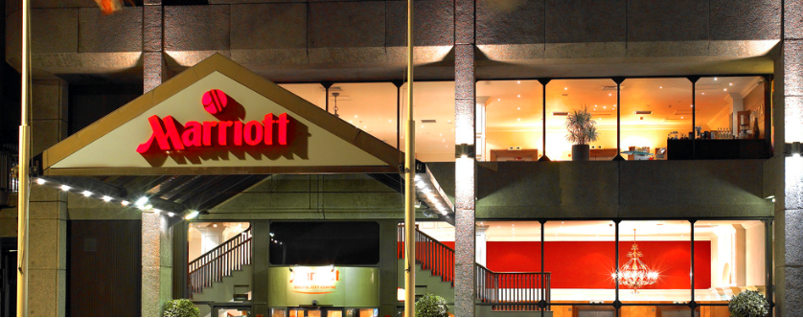

**BRISTOL MARRIOTT CITY CENTRE**

2 Lower Castle Street, Old Market, Bristol, England BS1 3AD United Kingdom

Phone: + 44 117 929 4281

**The Bristol Marriott Hotel City Centre offers warm hospitality in the**

**heart of the city centre. On the doorstep of Cabot Circus Shopping**

**Centre, cool contemporary style blends with traditional service,**

**providing a haven for clear thought and relaxation.**

**By Road** From the M4 take J19 signposted M32. Follow signs to the city centre. Turn left at Bond Street and follow signs to Broadmead Shopping Centre. The hotel can be found on Lower Castle Street.

**By Plane** Bristol Airport 9 miles.

**By Rail** Bristol Temple Meads Station is less than 1 mile.



**Car Parking**

The Bristol City Centre Marriott doesn’t offer onsite car parking; it is located next to the hotel in an NCP. Standard NCP rates are as follows:

* Up to 1 hour £3.50
* Up to 2 hours £6.50
* Up to 4 hours £9.50
* Up to 6 hours £15.50
* Up to 24 hours £21.00
* Early bird arrival before 09:00 and depart before 23:59 @ £8.50 (charges must be settled by the delegates on an individual basis)
* Overnight residents are offer a reduced rate of £17.00 per 24 hours

**The above rates are subject to change at any time according to NCP.**